ECSE 222 – DIGITAL LOGIC

VHDL ASSIGNMENT 2

LAB REPORT

Group:

|  |  |  |
| --- | --- | --- |
| Antoine Phan | - | 260 948 633 |
| Jakob Rylo | - | 261 028 769 |

# SUMMARY

# QUESTIONS

# FIGURES

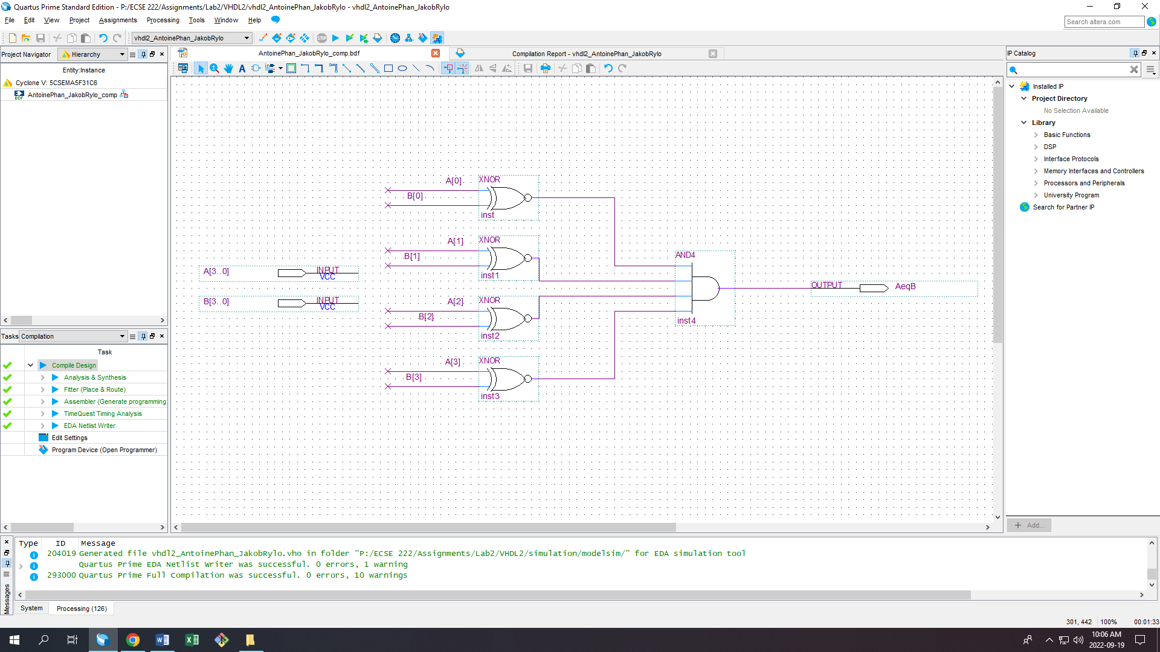

Figure 1: Schematic diagram design of the circuit

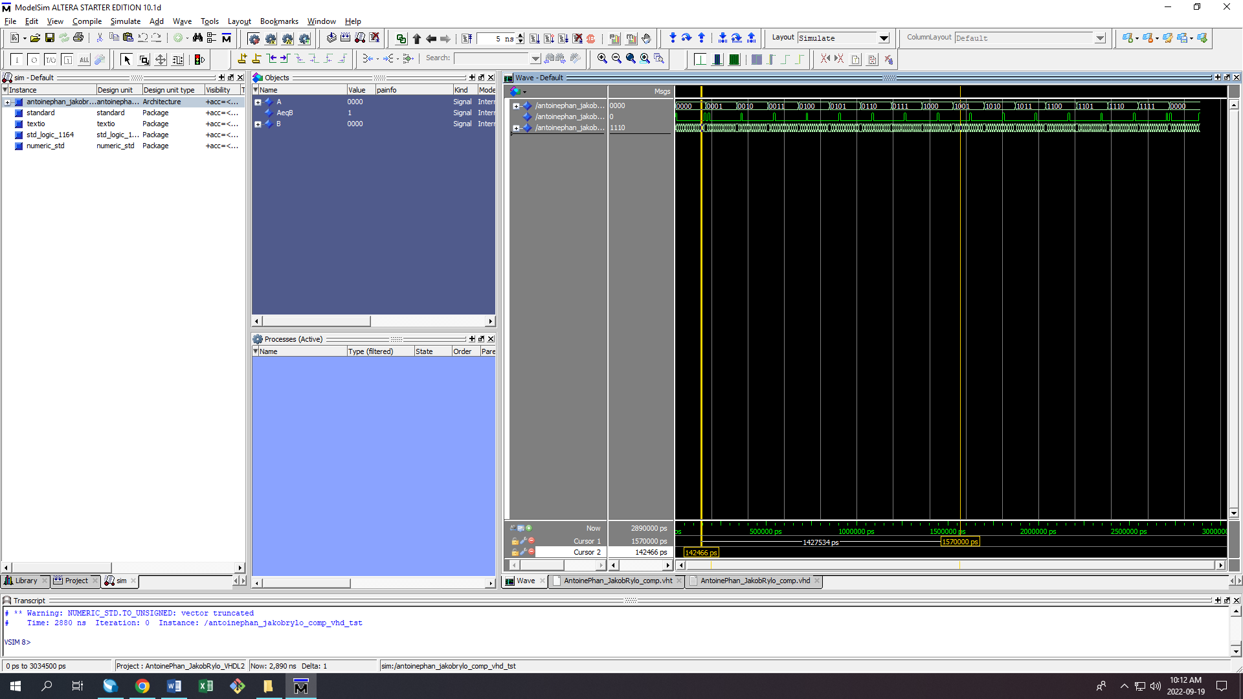

Figure 2.1: Simulation of the schematic diagram design (brute force)

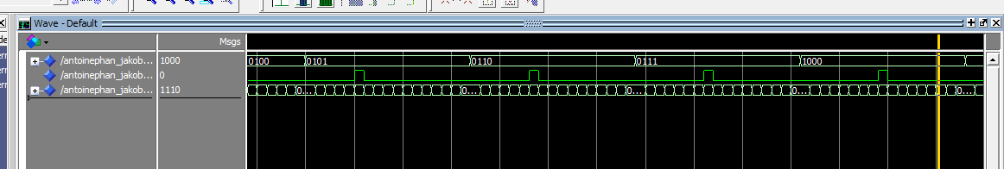

Figure 2.2: A close-up zoom-in of the simulation on ModelSim

# EXPLANATION

# CONCLUSION